**Experiment: 2**

PART A

(PART A: TO BE REFFERED BY STUDENTS)

**Aim:** **To study components of a C++ program.**

**Learning Outcomes: Learner would be able to**

1. Use Codeblocks IDE
2. Explain basic C program structure.
3. Develop and Execute CPP programs using basic programming constructs.

**Task1: Get acquainted with the code block IDE.**

In order to install the Code::Blocks IDE as well as the MinGW compiler, you must download it. You can download it for Windows from here:

<http://www.codeblocks.org/downloads/binaries>

**NOTE**: Select **codeblocks-17.12mingw-setup.exe** file which includes the GCC/G++ compiler.

**Create and run sample program:**

**/* My first C++ program */**

**#include <iostream>**

**int main()**

**{**

**cout<<”Welcome to C++ Programming”<<endl;**

**}**

**Task 2:** Following names are chosen by a programmer for using them as variable names. **Identify whether these names are valid or invalid. If invalid justify the reason.**

1. **100K**
2. **floatTotal**
3. **n1+n2**
4. **case**
5. **WoW!**
6. **While**
7. **intwidth?**

**Task 3:** Write a program to print employee details like employee number, name, and address and phone number.

**Task 4:** Write a program to evaluate the following expressions and display their results. Input

integers x , y, z from the user

a. x2 + 2x3 * (2*x)

b. x1 + y2+z3

**Task 5:** Convert the following steps into a C program

1. Start

2. Define variables: rollno, msub1, msub2, msub3, msub4, msub5, msum, score

3. Take input from keyboard for all the input variables

4. Calculate the sum of marks of 5 subjects and also calculate the percentage score as:

msum = msub1 + msub2 + msub3 + msub4 + msub5; Score = msum/500 × 100

5. Display roll number and percentage score.

6. Stop

**Task 6:** Find errors in the program given below: (**Do not type the code. Find error without executing**)

#include<iostream>

void main()

{

float speed, time, distance;

cout<<"Enter speed and time";

cin>> speed>>time

distance = speed * time

cout<<"\n The distance traversed is:”<<distance);

}

**Task 7:** Write a program to swap two integers with and without using temporary variables.

**Theory:**

**C Program Basics:**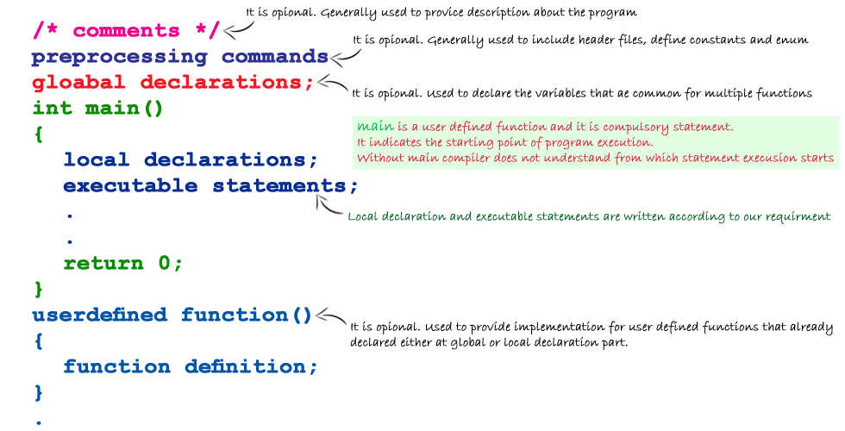

**Datatype:** Datatype is a set of value with predefined characteristics. Datatypes are used to declare variable, constants, arrays, pointers and functions.

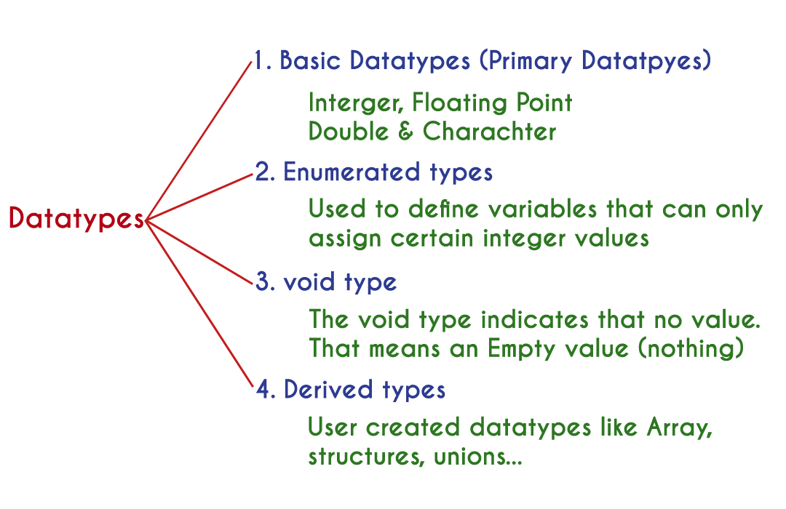

* 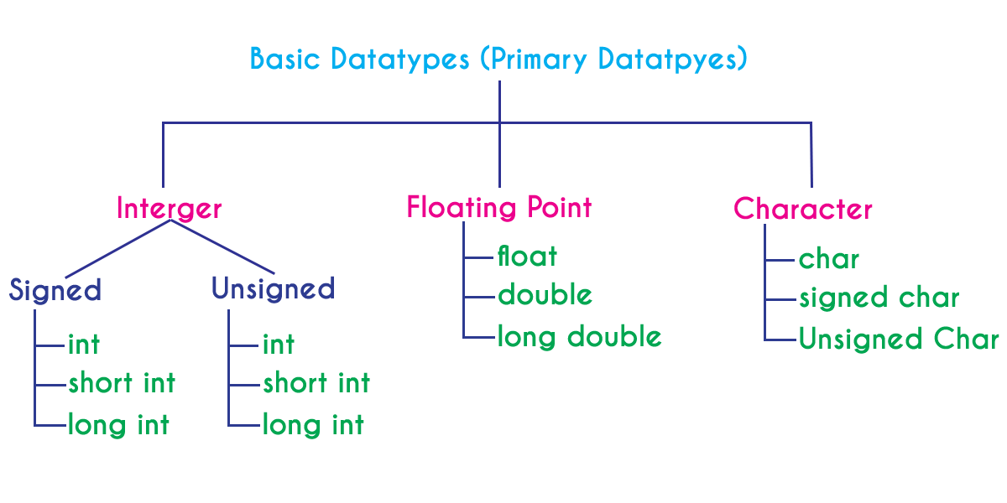

**Variable:**

* A variable is a data name that may be used to store a data value.
* Variable may take different values at different times during execution.
* A variable name can be chosen by the programmer in a meaningful way do as to reflect its function or nature in the program.
* Ex: average, amount, height , total
* Variable names may consist of letters, digits, and the underscore character.
* Variable should begin with letter. Some system permit underscore as first character.
* ANSI recognizes a length of 31 characters, however length should not be normally more than 8 characters, since only the first 8 characters are treated significant by many compilers.

**Declaration of variables:**

* After designing suitable variable names, we must declare them to the compiler. Declaration does two things:
* It tells the compiler what the variable name is.
* It specifies what type of data the variable will hold.
* Declaration of variable must be done before variable is used in program.
* General Syntax for declaring a variable:

data-type v1,v2,….,vn;

For ex: int total,age,amount;

float average;

double ratio;

short int count;

**Assigning values to the variable:**

* Values can be assigned to variable using the assignment operator = as follows:
* General syntax: variable_name = constant value;
* For ex :
  + - * total=10;
      * weight =50;
      * balance=10.5
* C permits multiple assignments in one line:
* For ex: total=0; sum=50;
* For ex: year=year+1;
* During assignment operation, C converts the type of value on the right hand side to the type on the left.

**Reading and Writing Data**

* Values can be provided to variables by writing cin statement
* General syntax for cin statement:
* Cin>>variable1>>variable2;
* When cin statement is encountered computer waits for user to enter the value with keyboard.
* Control string contains the format of data being received.
* For writing data cout statement is used.
* The general syntax for cout statement is
* cout<<“control string message”<<variable1;

#include<iostream>

Void main()

{

int number, total;

cout<<“\n enter value for number: “;

cin>>number>>total;

if(number<100)

cout<< “\n Your number is smaller than 100”;

cout<<endnl<<“number”<<number<<”total = ”<<total);

else

cout<<“\n Your number is greater than 100”;

}

PART B

(PART B: TO BE COMPLETED BY STUDENTS)

Students must submit the soft copy as per following segments within two hours of the practical. The soft copy must be uploaded on the portal at the end of the practical. The filename should be **PPS_batch_rollno_experimentno Example: PPS_B2_B001_Exp1**

|  |  |
| --- | --- |
| **Roll No.:** | **Name:** |
| **Prog/Yr/Sem:** | **Batch:** |
| **Date of Experiment:** | **Date of Submission:** |

Task 1:

Task 2:

Task 3:

Task 4:

Task 5:

Task 6:

Task 7:

**Conclusion (Learning Outcomes):** Reflect on the questions answered by you jot down your learnings about the basic constructs of C program.

**Homework Questions:**

1. Write an algorithm, draw flowchart and write C program to convert a distance entered in metres to kilometres.
2. Input the basic salary of a person. Calculate the dearness allowance (DA) as 15% of the salary and house rent allowance(HRA) as 5% of the salary. After this determine the gross salary.(gross =basic+DA+HRA).